# StrongDBMS Benchmark steps

## Server Initialisation

The Strong server is initialised using windows cmd prompt. In the case of Figure 1, the most up to date repository is found in E:\ShareableDataStructures-master\0.1\bin. As the default directory is set to the C: drive, the directory must be changed by entering the command “cd” followed by the desired path. “E:” is entered to change the path to the E: drive. As seen in Figure 1, “strongdb” is entered to run the executable file, “-d:\DATA” selects the path to access database files from the folder “DATA” (E:\DATA). The folder “DATA” is created before server initialisation to store the database “tpcc”. The user is then prompted to hit the “Enter” key on the keyboard to finalise the initialisation.

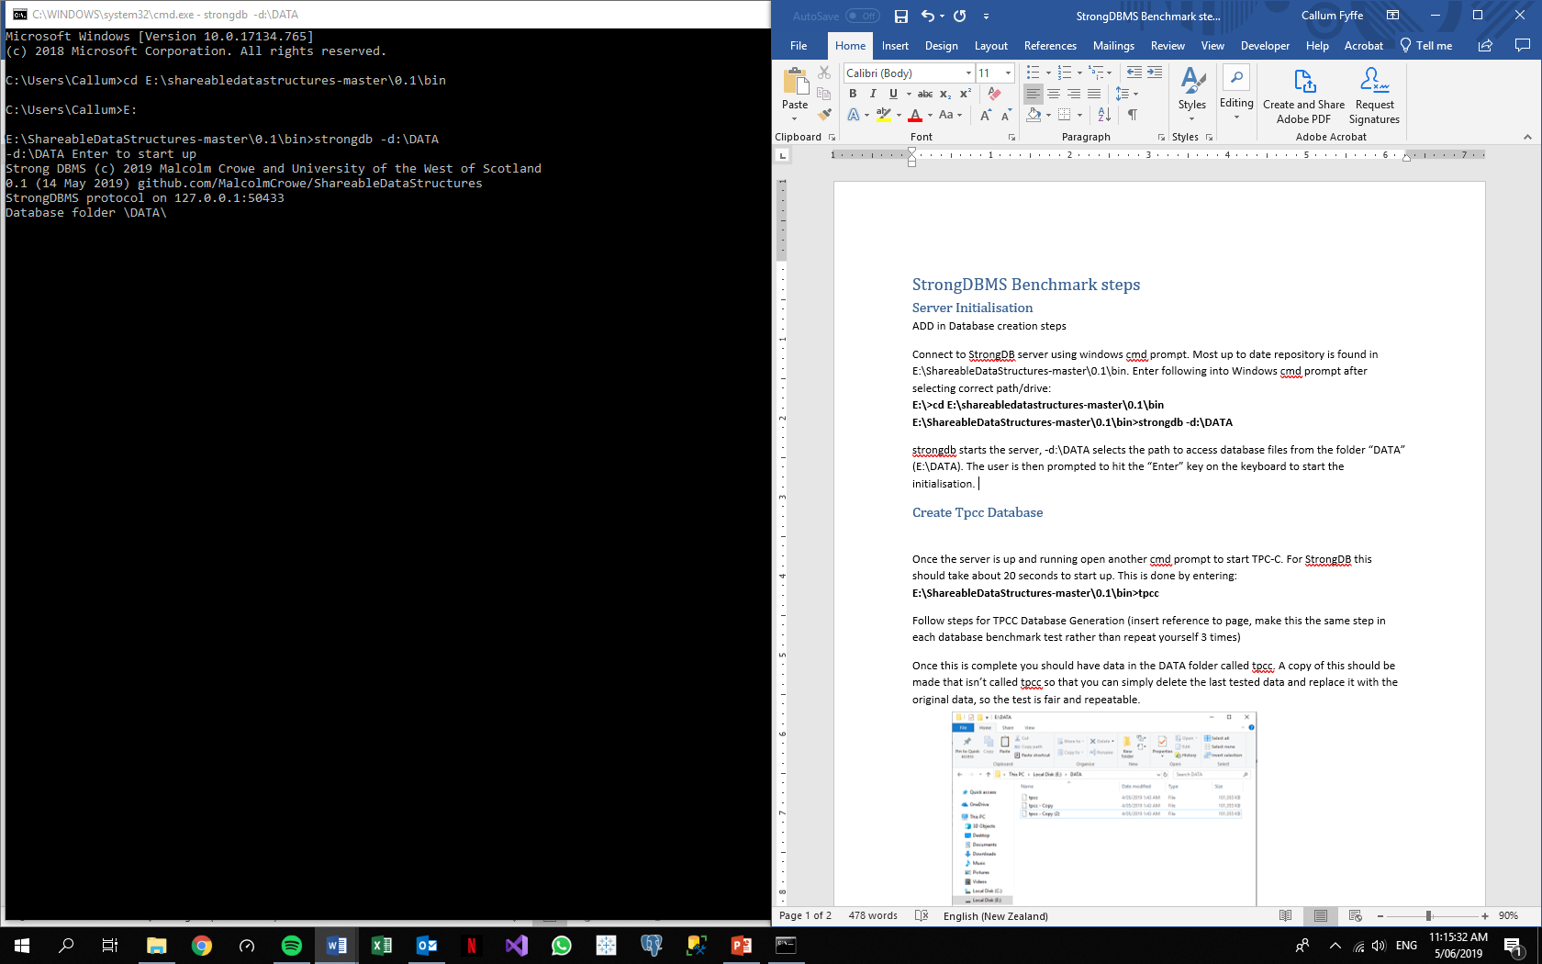

Figure : Strong Server Initialisation

## Create Tpcc Database

Once the server is running, another cmd prompt is opened to start the TPC-C application. For Strong this should take about 20 seconds to start up. The TPC-C application for Strong is found in the same path as the server initialisation file, “E:\ShareableDataStructures-master\0.1\bin” and the Strong TPC-C executable is called “tpcc”. The TPC-C application will create a database called “tpcc” by itself when it is run.

## Populate Tpcc

Refer to common Populate Database “Tpcc” section.

## Backup Database

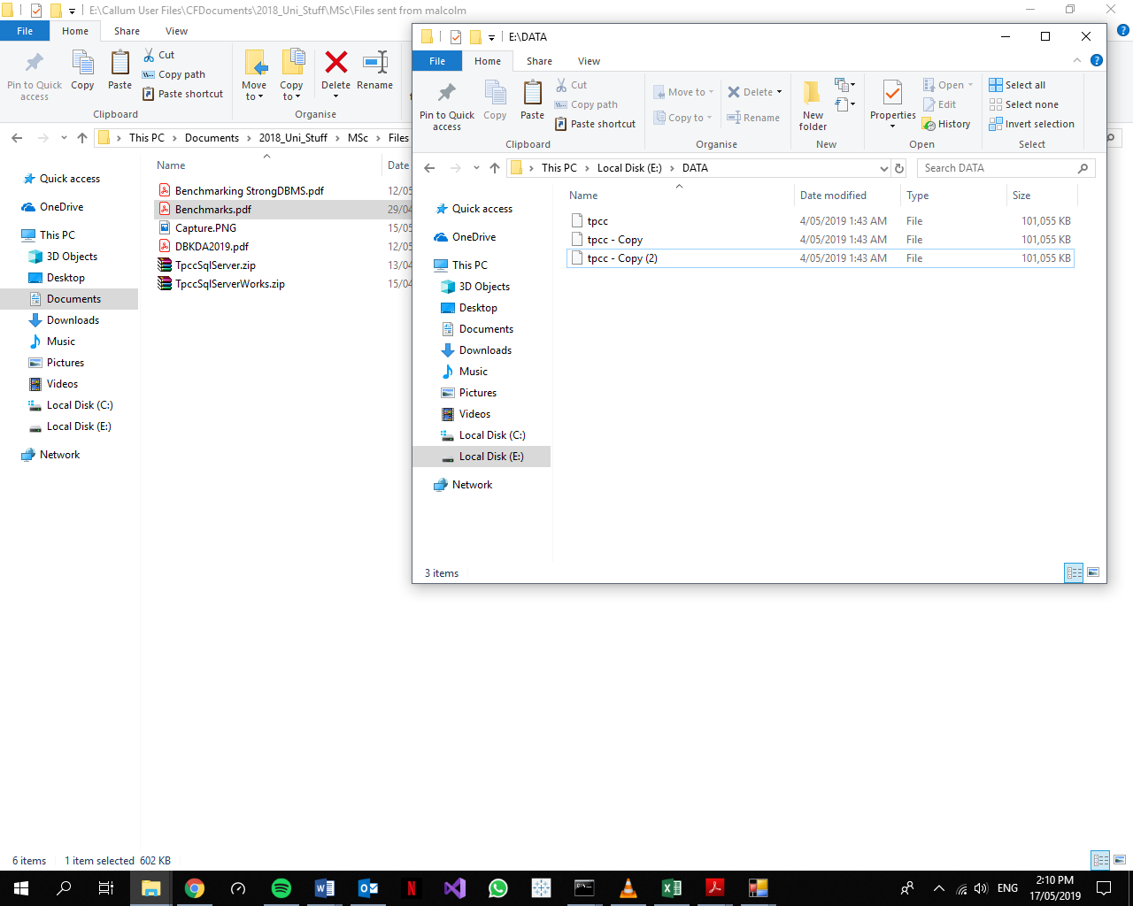Once the database is created and populated, a file in the “DATA” folder called “tpcc”, as seen in Figure 2, appears. The TPC-C application recognises this name and uses it for the benchmark. A copy of this is made that isn’t called “tpcc” so that the application doesn’t use it for the TPC-C test. This copy is used later on to restore the database to its original state.

Figure : DATA Folder

## Query for Table Condition

Before testing, the original state of the database is found by querying it. To open a client application window, the “strongcmd.exe” file must be executed from windows cmd prompt and told to open the database “tpcc”. The following query needs to be entered to view the status of the tables:

select from _Tables

The resulting table is copied by left clicking and dragging the mouse over the table and pressing “ctrl” + “c”. The cmd lines will be highlighted white. If the table is not highlighted white before pressing “ctrl” + “c”, the application will disconnect from the Tpcc database as it is a Windows keyboard shortcut for closing applications in the cmd window. The table is copied and pasted into a word file to keep for comparison. As seen in Figure 2, using Strong SQL syntax is used to find the number of tuples in tpcc’s tables.

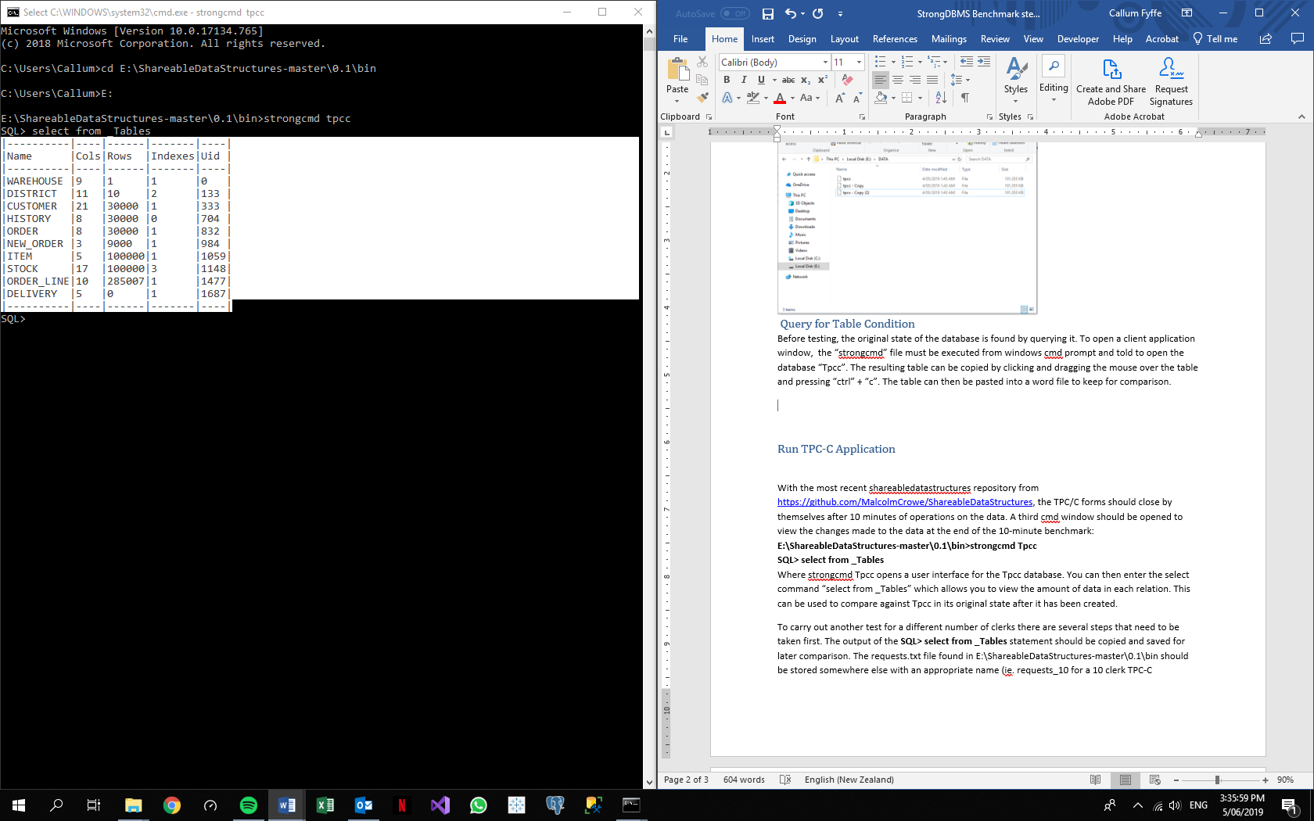

Figure : Strong Query for Table Condition

## Run TPC-C Application

Refer to common Run TPCC section.

## Result Collection

The query displayed in Figure 3 is run to display the tables’ properties then copied into a word document to be analysed later.

## Restore Database

The file named “Tpcc” in the “E:\DATA” folder is deleted after all instances of the Database are closed. A copy of the database is then renamed “Tpcc” for future tests.